**Housing Prices Prediction using Linear Regression**

**Description-** This project aims to predict housing prices using a linear regression model. By analyzing historical housing data, the model estimates the value of properties based on various features such as square footage, number of bedrooms, condition. The project includes data preprocessing, model training, and evaluation, providing a practical demonstration of how linear regression can be applied to real-world data for price prediction.

**Data Collection-** Downloaded a housing dataset from Kaggle, Take a look

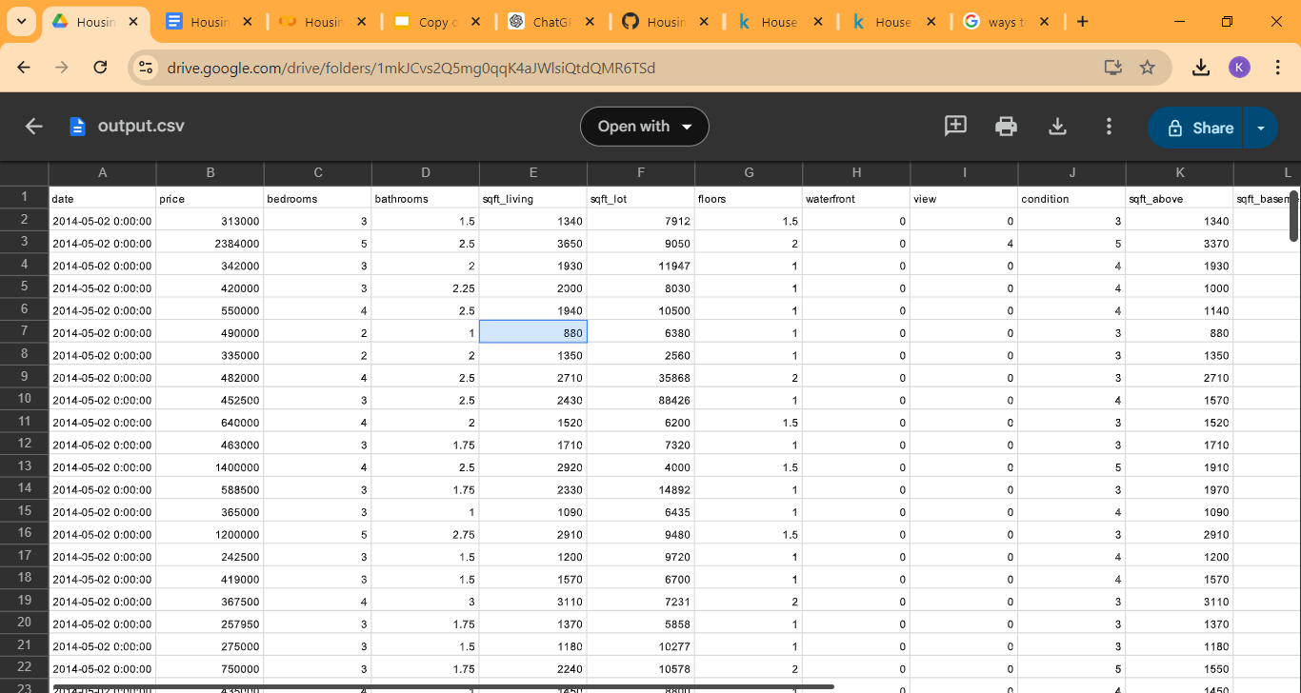

**Feature Selection-** I used 3 main features, number of bedrooms, number of Square feet, and the condition (1-5) in which a particular house is in.

**Data Preprocessing-** Fortunately, the data used is already clean!

**Model Training-** This model updates the weight values to determine what combination of values work best for the line. The model went through 5000 iterations to its current state

**Model Evaluation-** The metric used was Mean-Squared error